Chapter 6, Problem 80.

Figure 6.93 presents an analog computer designed to solve a differential equation. Assuming f(t) is known, set up the equation for f(t).

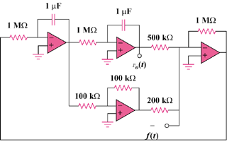

Figure 6.93
For Prob. 6.80.

